|  |  |  |  |  |  |  |
| --- | --- | --- | --- | --- | --- | --- |
|  | | | | | | |
| DEVICE | **Interface** | **IP Address** | **Subnet Mask** | **Default Gateway** |  |  |
| Router 1 | FastEthernet0/0 | 192.168.100.4 | 255.255.255.0 | N/A |  |  |
|  | FastEthernet1/0 | 172.16.10.15 | 255.255.255.0 | N/A |  |  |
| Router 2 | FastEthernet0/0 | 172.16.10.1 | 255.255.255.0 | N/A |  |  |
|  | FastEthernet2/0 | 192.168.200.0 | 255.255.255.0 | N/A |  |  |
|  | FastEthernet1/0 | 172.16.20.11 | 255.255.255.0 | N/A |  |  |
| Router 3 | FastEthernet0/0 | 172.16.20.12 | 255.255.255.0 | N/A |  |  |
|  | FastEthernet1/0 | 192.168.150..2 | 255.255.255.0 | N/A |  |  |
| PC 1 | FastEthernet0/0 | 192.168.100.7 | 255.255.255.0 | 192.168.100.1 |  |  |
| PC 2 | FastEthernet0/0 | 192.168.200.3 | 255.255.255.0 | 192.168.200.1 |  |  |
| PC 3 | FastEthernet0/0 | 192.168.150.2 | 255.255.255.0 | 192.168.150.1 |  |  |

Network A

Network C

Network B

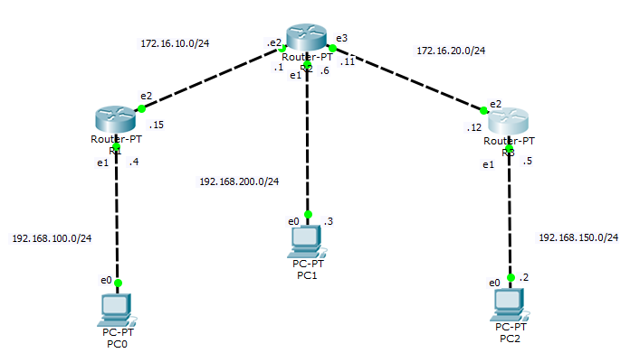  
Routing default R1

|  |  |  |  |
| --- | --- | --- | --- |
| Network Address | Network ID | Netmask Tujuan | Gateway |
| B | 0.0.0.0 | 255.255.255.0 | 172.16.10.1 |
| C | 0.0.0.0 | 255.255.255.0 | 172.16.10.1 |
|  |  |  |  |

Routing default R2

|  |  |  |  |
| --- | --- | --- | --- |
| Network Address | Network ID | Netmask Tujuan | Gateway |
| A | 0.0.0.0 | 255.255.255.0 | 172.16.10.15 |
| C | 0.0.0.0 | 255.255.255.0 | 172.16.20.12 |

Routing default R3

|  |  |  |  |
| --- | --- | --- | --- |
| Network Address | Network ID | Netmask Tujuan | Gateway |
| A | 0.0.0.0 | 255.255.255.0 | 172.16.20.12 |
| B | 0.0.0.0 | 255.255.255.0 | 172.16.10.1 |

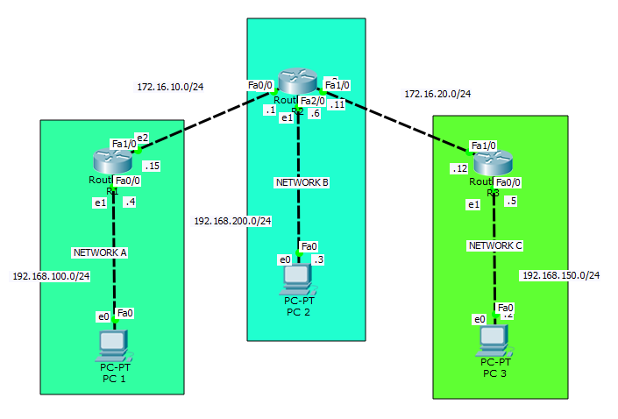

Routing Static R1

|  |  |  |  |
| --- | --- | --- | --- |
| Network Address | Network ID | Netmask Tujuan | Gateway |
| B | 192.168.200.0 | 255.255.255.0 | 172.16.10.1 |
| C | 192.168.150.0 | 255.255.255.0 | 172.16.20.1 |
|  |  |  |  |

Routing Static R2

|  |  |  |  |
| --- | --- | --- | --- |
| Network Address | Network ID | Netmask Tujuan | Gateway |
| A | 192.169.100.0 | 255.255.255.0 | 172.16.10.15 |
| C | 192.168.150.0 | 255.255.255.0 | 172.16.20.12 |

Routing Static R3

|  |  |  |  |
| --- | --- | --- | --- |
| Network Address | Network ID | Netmask Tujuan | Gateway |
| A | 192.169.100.0 | 255.255.255.0 | 172.16.20.12 |
| B | 192.168.200.0 | 255.255.255.0 | 172.16.20.11 |

Pengetesan IP Network Router dengan Ping

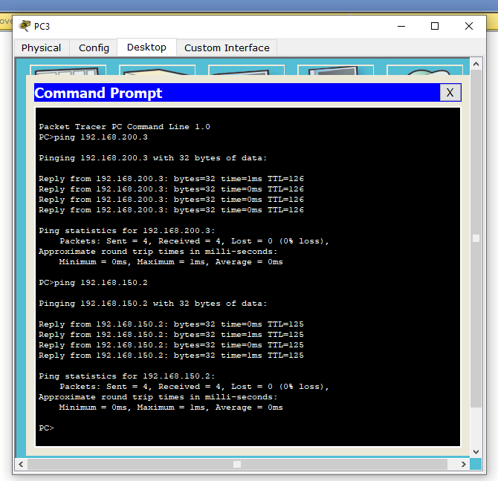Router 1

Router 2

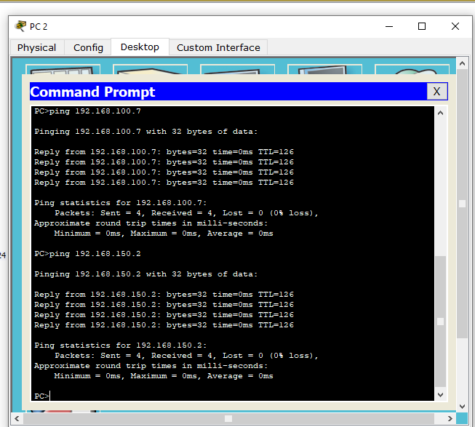

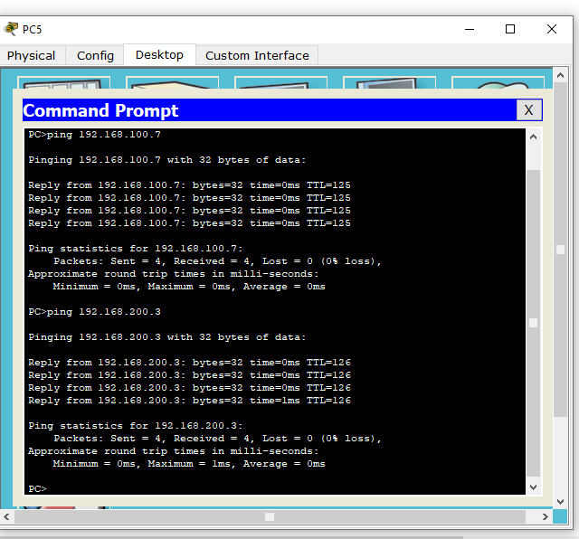Router 3